Training-Free Urban Anomaly Recognition Using Vision and Language Models

Linoy Halifa, Ezra Ella

Abstract
Urban environments contain a wide variety of safety-critical anomalies, including sidewalk cracks that endanger blind pedestrians, overgrown vegetation obstructing walkways or contacting power lines, dry bushes that increase fire risk, mispositioned trash bins, and the presence of dangerous objects or factors such as illegal weapons and shooters. Manually enumerating and training models on all such anomaly types is infeasible because their appearance, scale, and semantics vary dramatically across cities and contexts. Recent advances in vision–language models (VLMs) and multimodal large language models (MLLMs) suggest a promising alternative: training-free anomaly detection and reasoning using powerful pre-trained foundation models.
Building on prior work in training-free and zero-shot anomaly detection with vision–language models and large multimodal assistants [1-4,8-10], we propose a framework for training-free urban anomaly recognition that combines frozen vision language encoders with large language model (LLM) based risk reasoning.
Our system accepts images or video frames from heterogeneous datasets without any fine-tuning. It extracts region-level proposals, computes zero-shot anomaly similarity scores using frozen VLMs such as CLIP and LLaVA-like models [14,15]. Candidate regions are scored with zero-shot “normal vs. abnormal” prompts and urban hazard prompts, then passed to an LLM that assigns semantic categories and a risk-aware label: green (benign anomaly) or red (potentially dangerous anomaly), with a focus on risks to civilians, accessibility, and infrastructure safety. We plan to evaluate the framework on a mixture of existing open datasets for road damage, urban waste, and street-view infrastructure, and on repurposed driving datasets originally collected for autonomous driving. Evaluation will cover anomaly detection, localization, and risk classification. As a proof of concept, this work aims to show that training-free multimodal reasoning can generalize to diverse urban anomalies and support future smart-city deployments without requiring costly new data collection or retraining.

Introduction
Urban environments are dynamic, complex, and often fragile systems. Where even small anomalies as cracks in sidewalks, loose paving stones, misaligned manhole covers, overgrown vegetation, or improperly placed trash containers, can create serious risks for pedestrians, cyclists, and drivers. At the same time, more acute hazards such as fallen trees, flooded roads, fires, or the presence of weapons and violent actors pose immediate threats to public safety and infrastructure. Recent studies on urban road safety emphasize that such anomalies, along with broader traffic incidents, are a major cause of accidents and economic loss in cities worldwide[11,18].
Automatically detecting these diverse anomalies at scale remains challenging. Traditional computer vision pipelines for road or infrastructure monitoring typically rely on supervised detectors trained for specific categories such as potholes, cracks, or manholes[11]. Although highly effective in narrow domains, such models struggle to generalize to new cities, novel anomaly types, or long-tail corner cases. Even large road-damage datasets and street-view benchmarks (covering multiple countries and damage categories) do not fully capture the spectrum of semantically abnormal urban situations encountered in the real world [16,17]. For smart-city applications that aim to monitor pedestrian accessibility, vegetation risks, or context-specific hazards, re-annotating and re-training models for every new anomaly type is unsustainable.
In parallel, foundation models for vision and language have undergone rapid progress. Contrastive vision language models such as CLIP learn powerful open-vocabulary visual representations from web-scale image - text pairs, enabling zero-shot recognition of unseen categories[3]. Multimodal instruction-tuned models such as LLaVA extend this paradigm by connecting vision encoders to large language models and training them to follow natural-language instructions about images, yielding rich visual reasoning and explanation capabilities[4]. These advances naturally motivate training-free approaches to anomaly detection, in which pre-trained models are reused without dataset-specific fine-tuning.
Recent work has shown that vision-language foundation models can achieve strong performance in zero-shot or training-free anomaly detection across industrial and natural image domains. Zhang et al. proposed a training-free framework that integrates vision–language models with logical reasoning for structural and compositional anomaly detection, demonstrating state-of-the-art performance without additional training[5]. AnomalyCLIP adapts CLIP with object-agnostic prompt learning to capture generic “normal” and “abnormal” semantics, achieving superior zero-shot anomaly segmentation on diverse benchmarks[6] FiLo further refines this direction by generating fine-grained anomaly descriptions using LLMs and improving localization via multi-scale cross-modal interaction[7]. Complementary work by Ronecker et al. shows that high-level embeddings from vision foundation models can be exploited for purely semantic anomaly detection without any retraining or prompt engineering[8].
Beyond image-level anomaly scores, several studies now investigate anomaly reasoning with multimodal large language models. Xu et al. introduced Anomaly-OneVision, a framework that combines multimodal LLMs with zero-shot anomaly detection and explicit reasoning about abnormal regions and their causes[9]. AnomalyGPT integrates large vision–language models with simulated anomaly data to detect industrial anomalies, localize defects, and provide natural- language explanations without manual threshold tuning[10]. More recent methods such as AF-CLIP and diffusion-based generative approaches further expand the landscape of foundation-model- based anomaly detection, showing that lightweight adapters or generative scores can significantly improve zero-shot anomaly performance[11].
In the urban domain, vision-language models have started to be applied to road anomaly monitoring and smart-city analytics. Ding et al. proposed Urban Road Anomaly VLMs (URA-VLMs) for detecting road surface defects, garbage, floods, and other roadway anomalies in real time[12]. A concurrent survey on vision–language models for urban monitoring classifies emerging applications across traffic, infrastructure, and environmental monitoring, highlighting both the promise and open challenges of multimodal foundation models in cities[13]. Additional work explores VLMs and MLLMs for traffic anomaly detection in video, cross-domain video anomaly detection, and explanation of abnormal traffic events[14]. However, existing systems are typically tailored to road surfaces, traffic scenes, or industrial defects; they rarely address the full spectrum of urban anomalies relevant to pedestrians, accessibility, vegetation, fire risk, and security threats.
In this work, we target training-free urban anomaly recognition using vision and language models. We consider a broad definition of urban anomaly, including (i) structural hazards such as cracks, broken sidewalks, and misaligned infrastructure; (ii) environmental and vegetation-related risks such as overgrown plants blocking walkways, invasive species threatening local flora, or dry bushes that are easily ignited; (iii) misplacement anomalies such as trash bins or construction elements blocking paths; and (iv) high-risk security anomalies such as visible weapons or shooters in public space. Rather than training task-specific detectors for each class, we propose to leverage the open-vocabulary perception and reasoning capabilities of frozen VLMs and LLMs to detect previously unseen anomalies and to assess whether they pose a danger to civilians.
Our main contributions are:
- Define a training-free framework for urban anomaly recognition that combines frozen vision–language encoders with LLM-based risk reasoning to detect and categorize anomalies without any fine-tuning on target-city data.
- Introduce a risk-aware anomaly taxonomy in which anomalies are first detected broadly and then filtered by an LLM that classifies them as non-risk (green) or safety-critical (red), focusing on risks to civilians, accessibility, and infrastructure.
- Propose a dataset protocol that reuses existing open datasets for road damage, civic issues, and street scenes (e.g., BDD100K, street-view pavement damage datasets, and civic-issue image collections) as sources of diverse urban conditions without collecting new data[15].
- Outline an evaluation methodology for anomaly detection, localization, and risk classification across multiple anomaly categories, designed to test generalization across cities and datasets.
This paper focuses on the conceptual design and methodological details of the framework and its evaluation. Experimental results will be reported once the proof-of-concept implementation and benchmarking are completed.

Methods
Problem Formulation
We consider images or video frames of urban environments captured from ground-view cameras (e.g., vehicle-mounted cameras, fixed roadside cameras, or citizen reports). Given an image or video frame, the system must:
- If exist, identify one or more anomalous regions that deviate from expected urban semantics.
- Assign each region a semantic description e.g., “deep crack across the sidewalk”, “overgrown tree branches touching power line”, “trash bin blocking wheelchair ramp”.
- Classify each anomaly as either non-risk (green) or potentially dangerous (red) for civilians and/or infrastructure.
Formally, for each image or video frame we seek a set of regions R = {r₁, …, r_K}, each with a bounding box or mask, anomaly score a_k in [0,1] textual description d_k, and risk label ℓ_k in {green,red}. The framework is training-free in the sense that all visual and language encoders are used in frozen form; no fine-tuning is performed on task-specific urban anomaly data. Any future fine-tuning or adapter-based optimization is left for subsequent work.
Model Components
Vision–Language Backbone
For open-vocabulary perception, we employ CLIP-like vision-language encoders trained on large-scale image-text corpora. Specifically, we plan to use publicly available CLIP or OpenCLIP variants as backbone encoders, accessing their image and text embedding spaces. The image encoder produces a feature map F with dimensions H × W × D for each image, while the text encoder maps prompts into the same embedding space for similarity-based scoring.
For higher-level reasoning and description generation, we use an open multimodal assistant similar in spirit to LLaVA, which connects a vision encoder to a large language model and is instruction-tuned on multimodal data. This model is used without any task-specific fine-tuning to (i) generate region-level descriptions and (ii) perform risk-aware reasoning based on visual cues and anomaly candidates.

Region Proposal and Embedding Extraction
Given an input image, we first extract candidate regions that may contain anomalies. To remain training-free and general, we leveraging off-the-shelf, pre-trained segmentation or region proposal models (e.g., generic object detectors or segment-anything style models) to obtain a set of region proposals covering foreground objects, surfaces (sidewalks, roads, walls), and structures (poles, fences, vegetation clusters).
For each region proposal r_k, we pool its visual features from the backbone feature map F (for example, using masked average pooling) to obtain a region-level embedding v_k in a D-dimensional space. This yields a compact representation of each candidate region that can be compared against text embeddings.

Training-Free Anomaly Scoring
We adopt a two-stage anomaly scoring strategy inspired by training-free and zero-shot anomaly detection methods[18]. First, we define generic “normal vs. abnormal” prompts such as:
- “a normal, well-maintained urban sidewalk”
- “an urban scene with no damage or obstacles”
- “a damaged or broken sidewalk that is unsafe for pedestrians”
- “vegetation growing in a dangerous way, blocking a path or touching power lines”
- “a dangerous object or person, such as a gun or shooter, in a public place”
These prompts are encoded by the text encoder to yield text embeddings t_j. For each region embedding v_k, we compute cosine similarities s(k,j) = cos(v_k, t_j). A generic anomaly score a_k is obtained by comparing similarities to normal vs. abnormal prompts, for example:
a_k = σ( max over j in A of s(k,j) - max over j in N of s(k,j) ),
where A and N index the sets of abnormal and normal prompts, and σ is a sigmoid or calibration function. This stage captures whether a region is visually more consistent with “normal” or “abnormal” urban semantics without any training on anomaly labels.
Second, following ideas from FiLo and AnomalyGPT, we augment generic prompts with fine-grained descriptions derived from an MLLM. For each high-scoring region r_k, we query the multimodal LLM with context-aware questions such as:
- “Describe any damage, obstacles, or unusual objects in this region of the sidewalk.”
- “Does this vegetation pose a risk (e.g., blocking the way or touching electrical infrastructure)?”
- “Is there anything in this region that could endanger pedestrians or vehicles?”
The LLM’s textual descriptions are then re-encoded by the vision-language text encoder to form fine-grained anomaly prompts, refining the anomaly scores and improving localization, especially for subtle cracks or small obstacles.
Risk-Aware LLM Reasoning
Once candidate anomalies and fine-grained descriptions are available, we perform risk-aware reasoning using the LLM in a purely training-free manner. For each region r_k, we construct a structured textual context containing:
- Short description generated by the MLLM (e.g., “deep crack across the walking path”).
- Coarse anomaly type inferred from prompts (e.g., “surface damage”, “vegetation”, “trash”, “person”, “vehicle”).
- Global scene cues (e.g., presence of crosswalks, wheelchairs, children, or power lines) inferred by the MLLM.
We then ask the LLM to assign a risk label and explanation, for example:
- “Classify this anomaly as green (not dangerous) or red (dangerous) with respect to civilians. Give a short justification.”
Because the model has access to high-level world knowledge, it can reason about risks that are rarely, if ever, seen in the training data, for example, distinguishing between a small cosmetic crack and a deep fissure that could cause a wheelchair to tip, or determining that dry vegetation near a busy road constitutes a fire hazard. This risk reasoning layer is central to our goal: not only detecting anomalies, but also deciding which ones should be reported or prioritized.

Datasets
To demonstrate generalization across cities and anomaly types, we plan to evaluate the framework on a mixture of existing datasets originally created for road damage detection, pavement condition assessment, civic issue reporting, and driving scene understanding, all without any new data collection.
- Street-view pavement damage datasets. We include street-view image datasets for roadway and pavement damage detection, such as SVRDD, which provides annotated pavement damages in street-view images and is explicitly designed for automated road maintenance applications[20]. These datasets contain cracks, potholes, and surface irregularities relevant to sidewalk and road anomalies.
- Civic-issue and waste datasets. We leverage civic-issue image datasets that include potholes, garbage, and environmental cleanliness issues, such as the Urban Civic Issues Image Dataset, which provides annotated images of potholes and garbage for urban infrastructure monitoring and waste management[21]. Additional open trash/waste datasets are used as sources of misplacement anomalies as trash bins blocking paths.
- Driving datasets repurposed for sidewalks. We repurpose large-scale driving datasets such as BDD100K, originally collected for autonomous driving and multi-task learning, by focusing on sidewalks, roadside vegetation, and infrastructure in the periphery of the driving scene[22]. Frames are sampled to include diverse weather, time-of-day, and geographic conditions, and anomalies are mined via the training-free pipeline and manually verified for evaluation.
- Urban anomaly benchmarks from recent VLM works. Where licenses permit, we will reuse or align with urban anomaly subsets used in recent VLM-based anomaly detection and urban monitoring works e.g., URA-VLMs for road anomalies, traffic anomaly datasets processed by VLMs and MLLMs[23].
All datasets are used only for evaluation; the backbone models and LLMs remain frozen and are not fine-tuned on these data. Where necessary, a small subset of images is annotated with region-level anomaly and risk labels to support quantitative evaluation of detection, localization, and risk classification.

Evaluation Protocol
Tasks and Metrics
We consider three main evaluation tasks:
- Anomaly detection (image-level). Determine whether an image contains at least one anomaly. We compute standard metrics such as AUROC and AUPR over per-image anomaly scores e.g., maximum region anomaly score.
- Anomaly localization (region-level). Detect and localize anomalous regions. We evaluate region-level performance using metrics such as mean Average Precision (mAP) for anomaly detection at various IoU thresholds and pixel- level IoU where segmentation masks are available.
- Risk classification. Distinguish between non-risk (green) and dangerous (red) anomalies. For regions labeled as anomalies, we compute precision, recall, F1-score, and confusion matrices over risk labels. Category-level breakdowns e.g., cracks, vegetation, trash, security threats are reported in a summary table.
Baselines
We plan to compare our training-free framework against recent vision-language anomaly detection baselines that are freely available, including:
- AnomalyCLIP, which learns object-agnostic prompts for zero-shot anomaly detection[24]
- FiLo, which introduces fine-grained anomaly descriptions and high-quality localization using CLIP and LLM-generated prompts[25].
- Training-free VLM anomaly detection frameworks such as LogSAD: a novel multi-modal framework that requires no training for both Logical and Structural Anomaly Detection [26].
- VLM/MLLM anomaly reasoning methods including AnomalyGPT and other foundation-model-based anomaly detectors where configurations are available without commercial licenses[27].
Where methods require training on auxiliary industrial datasets (e.g., AF-CLIP), we will either use publicly released models or report qualitative comparisons rather than re-training on new urban data[28].
Implementation Considerations
Because the framework must remain training-free and reasonably simple, we avoid using complex metadata or city-specific knowledge. Instead, we rely on the generalization capabilities of vision-

language encoders and LLMs. To keep computational cost manageable for a proof of concept, we focus on:
- Single-frame analysis with optional temporal smoothing for video sequences.
- A moderate number of region proposals per frame e.g., top-K regions by saliency or objectness.
- A compact prompt set that covers generic normal/abnormal semantics and a small number of hazard archetypes e.g., structural, vegetation, waste, security.
Real-time performance and large-scale deployment as across entire cities are considered future work. In this article, we concentrate on validating whether training-free multimodal reasoning can reliably identify and prioritize urban anomalies using only existing models and datasets.
Results
We evaluated the capacity of two large language models (LLMs), ChatGPT-5.1 and Gemini-2.5 Pro, to detect visual anomalies and to infer the associated risks for pedestrians, cyclists, and drivers. Both models were able to identify anomalies; however, ChatGPT-5.1 demonstrated the highest interpretative accuracy, providing clearer and more precise explanations of the observed abnormalities (Fig. 1a-b). We also noticed that both LLMs recognized AI-generated glitches like wrong numbers, or upside symbols as major anomalies in the image, and failed to detect the risky anomalies, suggesting that AI generated images can mislead LLM that would fail at the reasoning step (Fig. 1c).
We further assessed ChatGPT-5.1 & Gemini 2.1 by presenting two distinct images and requiring the model to determine which scenario represented a more severe risk. Both models successfully ranked the images according to the relative severity of the hazards posed to civilians and did so using a consistent and intuitive rationale. While ChatGPT-5.1 marked trash cans at the collection day as a risk, Gemini 2.5Pro has decided that this anomaly is normal for trash collection day and kept the original image with no anomaly highlights (Fig. 2).
When an enhanced the prompt for better reasoning, and tested the results in zero-shot using ChatGPT-5.1 Pro, in result, the chat has managed to recognize driving directions, provide a score and create an overlay with risk scores on the image (Fig. 3)

Figure 1a
Original image | ChatGPT 5.1 | Gemini 2.5Pro | Best model
 | 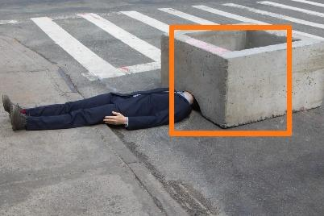 |  | Gemini: better highlight of abnormality
Text | The image shows a person in a suit lying on the ground with their head positioned under a very large concrete block.  In reality, this would be extremely dangerous and likely impossible without injury, so it’s almost certainly staged or an art installation. Still, the scene looks alarming because:  - The person is lying flat in the street.  - Their head is underneath the heavy concrete structure.  - The block appears far too heavy for a person to be safely beneath | The main issue is a person dressed in a suit who is lying flat on the public sidewalk.  What makes this especially strange is that their head and shoulders are inserted into the opening of a large, square concrete planter (or barrier). This is not a normal or safe position for a person to be in | ChatGPT: better understanding that the image is a part of scene

Figure 1b
Original image | ChatGPT 5.1 | Gemini 2.5Pro | Best model
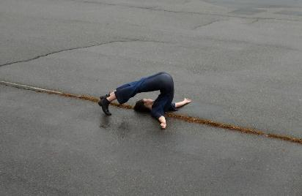 | 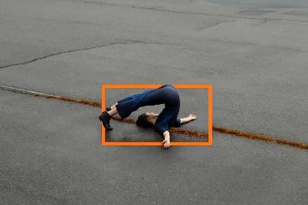 | 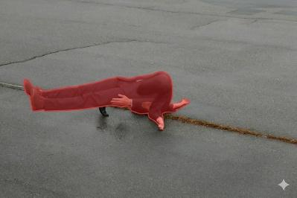 | ChatGPT: Kept original image
Text | The person’s body is bent backward in an extreme arch, but the bend is far beyond normal human spinal flexibility.  Their head and shoulders are pressed flat against the ground while their legs remain fully extended upward, forming a continuous curve that looks more like a rubber mannequin than a real spine.  The pose crosses the boundary of biological movement—it appears to be either:  a digitally manipulated image,  a staged artistic illusion,  or a doll/prop rather than an actual person.  Nothing in the environment is dangerous—it's purely the body posture that is unnatural. | The anomaly is the person lying on their back in the middle of a wet asphalt surface, with their legs inverted over their head in what appears to be a yoga or acrobatic pose. While the pose itself might be intentional, it's highly unusual and out of place to be performed casually in the middle of what looks like a street or parking lot, especially given the wet ground. The unusual context makes it an anomaly. | Gemini: Better interpretation of the situation and context.

Figure 1c
Original image | ChatGPT 5.1 | Gemini 2.5Pro | Best model
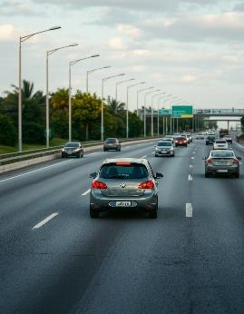 | 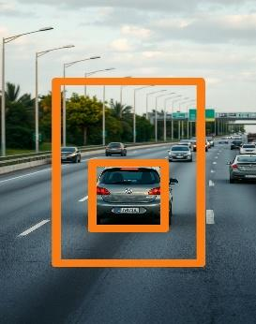 | 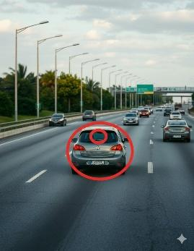 | None: Both failed to detect cars traveling in the opposite direction
Text | The central car (the Volkswagen) shows a rear license plate that is clearly impossible / nonsensical — the characters are distorted in a way that real plates never are.  This usually indicates:  an AI-generated plate,  privacy blurring gone wrong,  or digital manipulation.  Everything else (lanes, cars, lighting) looks normal. | The Volkswagen (VW) logo on the back of the grey car in the foreground is upside down. | ChatGPT: managed to understand it’s not a real image
Figure 2
Original images | ChatGPT 5.1 | Gemini 2.5Pro
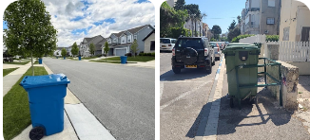 | 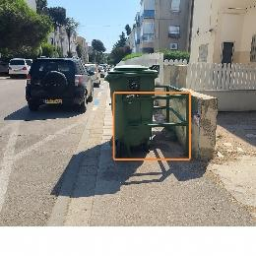  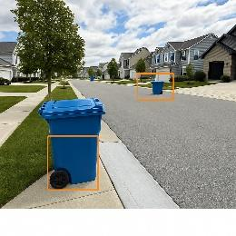 | 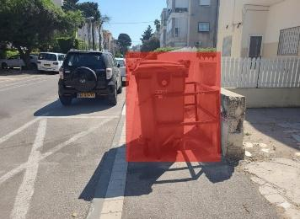
Text | Image 2 is significantly more dangerous.  Reason:  - It creates a direct and constant pedestrian safety hazard, especially for children, elderly, and disabled people.  - It forces foot traffic into the road, where cars are close and visibility is limited.  - The risk is systemic, not a one-time anomaly.  By comparison, Image 1 has road obstructions that can cause issues but in a quieter, controlled residential setting with wider visibility. | Image 2 is significantly worse and poses a much greater risk.  Image 1 depicts a normal, safe situation.(no changes were done to the image)  Image 2 shows a permanent-looking obstruction that creates an active and immediate danger for any pedestrian trying to use the sidewalk.

Figure 3: Zero shot risk analysis by ChatGPT with an enhanced prompt.
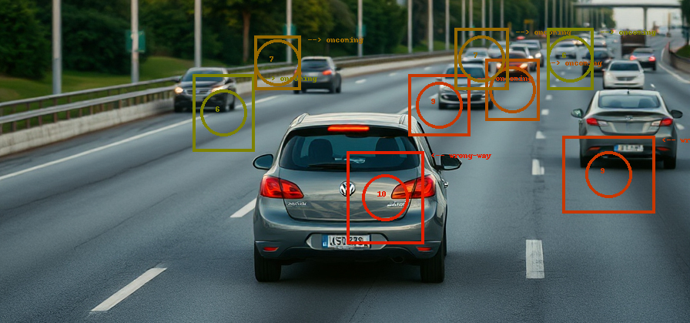

Initial results in the code: We ran our data (not in its entirety) in the model that the authors of the article “Towards Training-free Anomaly Detection with Vision and Language Foundation Models” propose and these are the initial results we received.

Table 1
category | K-shots | F1-Max(image) | AUROC(image) | F1-Max (logical) | AUROC (logical) | F1-Max (structural) | AUROC (structural)
cars | 4 | 83.33 | 67.56 | 66.67 | 70 | 76.92 | 66.33

Discussion
The results suggest that multimodal LLMs—especially ChatGPT-5.1—are capable of higher-order visual reasoning involving anomaly detection, causal inference, and risk prioritization. This combination is rare among existing AI models and indicates substantial progress toward unified vision-language systems that can assist in real-world safety analysis.

References
- Zhang, Y., Li, T., Wang, H., & Liu, X. (2025). Towards Training-Free Anomaly Detection with Vision and Language Foundation Models. CVPR 2025.:contentReference[oaicite:29]{index=29}
- Zhou, Q., Pang, G., Tian, Y., He, S., & Chen, J. (2023). AnomalyCLIP: Object-Agnostic Prompt Learning for Zero-Shot Anomaly Detection. ICLR 2024.:contentReference[oaicite:30]{index=30}
- Gu, Z., Zhu, B., Zhu, G., Chen, Y., Li, H., Tang, M., & Wang, J. (2024). FiLo: Zero-Shot Anomaly Detection by Fine-Grained Description and High-Quality Localization. ACM Multimedia 2024.:contentReference[oaicite:31]{index=31}
- Ronecker, M. P., Foutter, M., Elhafsi, A., Gammelli, D., Barakaiev, I., Pavone, M., & Watzenig, D. (2025). Vision Foundation Model Embedding-Based Semantic Anomaly Detection. arXiv:2505.07998.:contentReference[oaicite:32]{index=32}
- Xu, J., Lo, S.-Y., Safaei, B., Patel, V. M., & Dwivedi, I. (2025). Towards Zero-Shot Anomaly Detection and Reasoning with Multimodal Large Language Models. CVPR 2025.:contentReference[oaicite:33]{index=33}
- Ding, H., et al. (2025). Urban Road Anomaly Monitoring Using Vision–Language Models for Enhanced Safety Management. Applied Sciences, 15(5), 2517.:contentReference[oaicite:34]{index=34}
- Anonymous. (2025). Towards General Urban Monitoring with Vision-Language Models. arXiv:2510.12400.:contentReference[oaicite:35]{index=35}
- Gu, Z., Zhu, B., Zhu, G., Chen, Y., Tang, M., & Wang, J. (2023/2024). AnomalyGPT: Detecting Industrial Anomalies Using Large Vision-Language Models. AAAI 2024 & arXiv:2308.15366.:contentReference[oaicite:36]{index=36}
- Fang, Q., Lv, W., & Su, Q. (2025). AF-CLIP: Zero-Shot Anomaly Detection via Anomaly-Focused CLIP Adaptation. ACM Multimedia 2025.:contentReference[oaicite:37]{index=37}
- Abdi, L., Valiuddin, A., Caetano, F., Viviers, C., & van der Sommen, F. (2025). Zero-Shot Image Anomaly Detection Using Generative Foundation Models. ICCV 2025 Workshops (ADFM).:contentReference[oaicite:38]{index=38}
- Biswas, D., et al. (2025). MMVAD: A Vision–Language Model for Cross-Domain Video Anomaly Detection. Expert Systems with Applications.:contentReference[oaicite:39]{index=39}
- Zheng, Y., et al. (2025). Video-Based Traffic Anomaly Detection with Vision-Language Models. IEEE ITSC 2025 (preprint).:contentReference[oaicite:40]{index=40}
- Almakhluk, A., Baroudi, U., & El-Alfy, Y. (2025). Intelligent Road Anomaly Detection with Real-time Notification System for Enhanced Road Safety. arXiv:2505.08882.:contentReference[oaicite:41]{index=41}
- Liu, H., Li, C., Wu, Q., & Lee, Y. J. (2023). Visual Instruction Tuning. NeurIPS 2023 (LLaVA).:contentReference[oaicite:42]{index=42}
- Radford, A., Kim, J. W., Hallacy, C., et al. (2021). Learning Transferable Visual Models From Natural Language Supervision. ICML 2021 (CLIP).:contentReference[oaicite:43]{index=43}
- Yu, F., Chen, H., Wang, X., et al. (2020). BDD100K: A Diverse Driving Dataset for Heterogeneous Multitask Learning. CVPR 2020.:contentReference[oaicite:44]{index=44}
- Ren, M., et al. (2024). An Annotated Street View Image Dataset for Automated Road Surface Condition Assessment (SVRDD). Data in Brief.:contentReference[oaicite:45]{index=45}
- Anonymous. (2025). Urban Civic Issues Image Dataset: Potholes and Garbage. Mendeley Data, V1, 2025.:contentReference[oaicite:46]{index=46}

